Lab #7: Normalization One

**Part One:**

1. I would first say thank you for the work he has put together and that all of the data that we need looks to be in the chart. The one aspect I would comment on would be how he organized the chart. There is a better way to do so that would make it easier in the long run in terms of referring back to this data. The biggest change would have to be creating separate rows for every repeating Package ID. Although it may seem fine to bunch them together it can cause problems.
2. 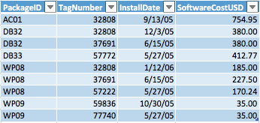
3. The Primary key has to include both the PackageId and the TagNumber

**Part Two:**

1. 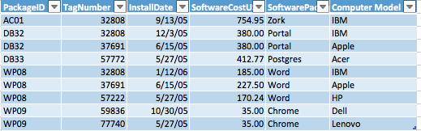
2. (PackageID, TagNumber) 🡪InstallDate

(PackageID, TagNumber) 🡪SoftwarePriceUSD

PackageID 🡪 SoftwarePackageName

TagNumber 🡪 ComputerModel

1. This table is not in third normal form because it has non-key attributes that are dependent on other non-key attributes. What this means is that SoftwarePackageID is dependent on PackageID and ComputerModel is dependent on TagNumber. None of these are the primary key for the table since the primary key is a combination of both the PackageId and TagNumber.

**Part Three:**

1. 

Primary Key- (PackageID, TagNumber)

(PackageID, TagNumber) 🡪InstallDate

(PackageID, TagNumber) 🡪SoftwarePriceUSD

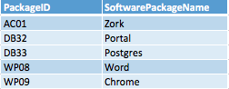

Primary Key – PackageID

PackageID 🡪 SoftwarePackageID

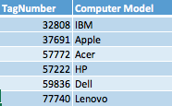

Primary Key – TagNumber

TagNumber 🡪 ComputerModel

These new tables were all put into third normal form after the non-key attributes that were dependent on other non-key attributes were moved into their own tables. Now each table is dependent on their primary key only.